## Simple Moving Averages

A simple moving average (SMA) is an arithmetic [moving average](https://www.investopedia.com/terms/m/movingaverage.asp) calculated by adding the [closing price](https://www.investopedia.com/terms/c/closingprice.asp) of the security for a number of time periods and then dividing this total by the number of time periods.

## The simple moving average formula is calculated by taking the average closing price of a stock over the last "x" periods. To calculate the simple moving average formula you divide the total of the closing prices and divide it by the number of periods.

As shown in the chart above, many [traders](https://www.investopedia.com/terms/t/trader.asp) watch for short-term averages to cross above **longer-term averages** to signal the beginning of an [uptrend](https://www.investopedia.com/terms/u/uptrend.asp). **Short-term averages** can act as levels of support when the price experiences a [**pullback**](https://www.investopedia.com/terms/p/pullback.asp).

## Simple Moving Average (SMA)

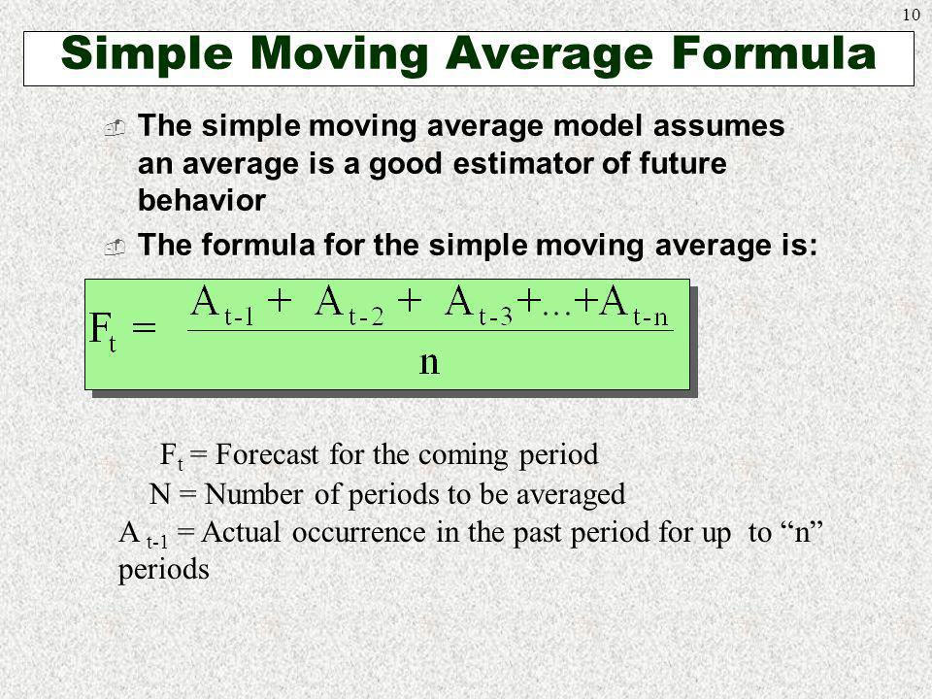

Let's take a look at a simple moving average example with MSFT.  The last five closing prices for MSFT are:

28.93+28.48+28.44+28.91+28.48 = 143.24

To calculate the simple moving average formula you divide the total of the closing prices and divide it by the number of periods.

5-day SMA = 143.24/5 = 28.65

## Calculation-

|  |  |  |  |  |  |
| --- | --- | --- | --- | --- | --- |
| **Date** | **Open** | **High** | **Low** | **Close** | **Simple Moving Avg(Close)** |
| 1/3/2012 | 325.25 | 332.83 | 324.97 | 663.59 |  |
| 1/4/2012 | 331.27 | 333.87 | 329.08 | 666.45 |  |
| 1/5/2012 | 329.83 | 330.75 | 326.89 | 657.21 |  |
| 1/6/2012 | 328.34 | 328.77 | 323.68 | 648.24 |  |
| 1/9/2012 | 322.04 | 322.29 | 309.46 | 620.76 |  |
| 1/10/2012 | 313.7 | 315.72 | 307.3 | 621.43 | 651.25 |
| 1/11/2012 | 310.59 | 313.52 | 309.4 | 624.25 | 642.818 |
| 1/12/2012 | 314.43 | 315.26 | 312.08 | 627.92 | 634.378 |
| 1/13/2012 | 311.96 | 312.3 | 309.37 | 623.28 | 628.52 |
| 1/17/2012 | 314.81 | 314.81 | 311.67 | 626.86 | 623.528 |
| 1/18/2012 | 312.14 | 315.82 | 309.9 | 631.18 | 624.748 |
| 1/19/2012 | 319.3 | 319.3 | 314.55 | 637.82 | 626.698 |
| 1/20/2012 | 294.16 | 294.4 | 289.76 | 584.39 | 629.412 |
| 1/23/2012 | 291.91 | 293.23 | 290.49 | 583.92 | 620.706 |
| 1/24/2012 | 292.07 | 292.74 | 287.92 | 579.34 | 612.834 |
| 1/25/2012 | 287.68 | 288.27 | 282.13 | 567.93 | 603.33 |
| 1/26/2012 | 284.92 | 286.17 | 281.22 | 566.54 | 590.68 |
| 1/27/2012 | 284.32 | 289.08 | 283.6 | 578.39 | 576.424 |
| 1/30/2012 | 287.95 | 288.92 | 285.63 | 576.11 | 575.224 |
| 1/31/2012 | 290.41 | 290.91 | 286.5 | 578.52 | 573.662 |

**Use Cases**

* **Used in stockmarket to find the fluctuations.**
* **Acceleration moving averges is used Fetcher[Show stocks where high crossed below the lower *acceleration band*(20)] .**
* **Used in Bussiness ,Health care Sectors etc.**

**Python**

**import numpy as np**

**dataset=[1,9,6,8,8]**

**def movingaverage(values,window) :**

**weights=np.repeat(1.0,window)/window**

**smas=np.convolve(values,weights,'valid')**

**return smas**

**movingaverage(dataset,3)**

**print( movingaverage(dataset,3))**

OutPut:

[5.33333333 7.66666667 7.33333333]